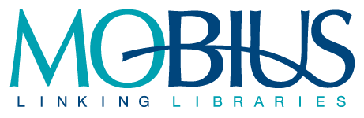

Minutes of the MOBIUS Digitization Committee
August 20, 2021, 3:00PM to 4:00PM, via Zoom

Members Present
- Debra Loguda-Summers, A.T. Still University
- Sarah Smith, St. Louis Community College
- Rebecca Hamlett, William Jewell College
- Emily Jaycox, Missouri History Museum
- Steven Pryor, University of Missouri-Columbia
- Adrienne Detwiler, MOBIUS
- Donna Bacon, MOBIUS

Members Absent
- Rebecca van Kniest, Fontbonne University
- Davina Harrison, Missouri Botanical Garden
- Jessica Vest, Northwest Missouri State University
Meeting Minutes

- Introductions

- Old Business
- The state has signed off on the finished grant.

- New Business
- The next grant involves a two-step process that includes submitting the letter of intent and then being invited to apply for the grant. The deadline for submitting the letter of intent is in December. The grant deadline has not been announced but will probably be in February.
- Ten libraries said they would like assistance with outsourcing digitization. The next step will be to get quotes from digitization vendors so that we can plug numbers into the grant application. We will need to get three quotes.
- The types of materials include yearbooks, student newspapers, microfilm, and campus bulletins. The libraries are novices when it comes to outsourcing digitization and do not have staff to do imaging. We will need to provide guidance and best practices.
- Rebecca Hamlett asked whether we are looking for a project-based quote or a quote based on number of pages, format, and type of conversion. She will bullet point some questions to send to the group.
- We will need to contact NEDCC about training and mentoring. Sean is gone so we will have a new trainer, but we do not have to rebid. NEDCC will assign someone else to the project.
- Donna will get a quote from Innovative for loading the data into Vital.
- We discussed using Basecamp for this round of the project.
- Emily received a request to partner with Iowa on a Missouri-Iowa Hub. Iowa has a group of 5 libraries with digital content they would like to contribute. The membership fee would be recalculated. A single hub pays $10,000 per year. Two or more hubs pay $15,000 per year. An official partnership means we would have libraries in Iowa to share the bill and participate in committee work. They will talk to DPLA and their state librarian. They have been invited to the annual meeting in October.

- Next meeting
  - We will send a doodle poll to schedule the next meeting. It will be sometime in mid-September.

- Minutes submitted by Adrienne Detwiler

