Minutes of the MOBIUS Circulation and Courier Committee Meeting
Monday, January 24th, 2022, at 10:00 am
Online, via Zoom

Members Present:
Sarah Brown, 2020-2022, Chair
Manager, Acquisitions & Collection Development, St. Louis County Library
Sarah Francka-Jones, 2021-2023, Vice-Chair
Interlibrary Loan Coordinator, Springfield-Greene County Library
Crystal Rhodes, 2020-2022
Public Services Librarian, Crowder College
Samantha Setzer, 2020-2022
Library Services Specialist, Moberly Area Community College
Lisa Young, 2021-2023
Director of Access Services, Lindenwood University
Steve Strohl, MOBIUS Organizer
Associate Director, Member Services, MOBIUS
Members Absent:
Lisa Farrell, Board Representative
Director of Library Services, East Central College
Phyllis Holzenberg, 2020-2022
ILL Librarian, Drury University
Donna Bacon, Ex-Officio
Executive Director, MOBIUS

- Call to order at 10:06 am by Sarah Brown.

- Adoption of the agenda motion made by Samantha Setzer, seconded by Sarah Francka-Jones, without objections.

- Information Items
  - Brief update on the ILS-RFP Committee.
    - Steve Strohl mentioned that the deadline for responses was moved back a week due to a request by one of the vendors due to COVID. The new due date for responses is now February 8th.
  - HELP – we need to place an order of the adhesive labels and we need to get a few more commitments before we place the order!
    - Steve mentioned that we need to send out one more reminder about the green, adhesive labels since we have a five-box minimum due to the color we’ve selected (dark green).
    - Sarah Brown mentioned going forward that they would order their labels through MOBIUS (to make our ordering process a bit easier).
    - Sarah Brown mentioned that they’ve heard that it will take months for their labels to come in so we should consider ordering them right away.
      - UPDATE: Right now, it could take 8 additional weeks (sometime in April) for labels to come in. I’ve indicated we would like to get in line now so that’s the earliest we can expect any labels. A message will go out about this shortly.
    - Steve asked Sarah Brown if the new adhesive labels will work with their new Polaris system, and she mentioned she would inquire with Innovative about this and follow-up with us.

- Unfinished Business
  - New courier survey will get discussed in the lead up to our next scheduled meeting. Links are below!
    - 2019 Survey
    - 2018 Survey
      - Steve is going to send out the agenda (again, thanks to our email issues with MOBIUS) and the PDF links for the previous two surveys. The goal will be to collaborate on a Google Doc on questions to go out (finalized during our March 14th meeting).
      - The link to the shared, editable, Google Doc is here.
  - Courier slips
    - Example 1:
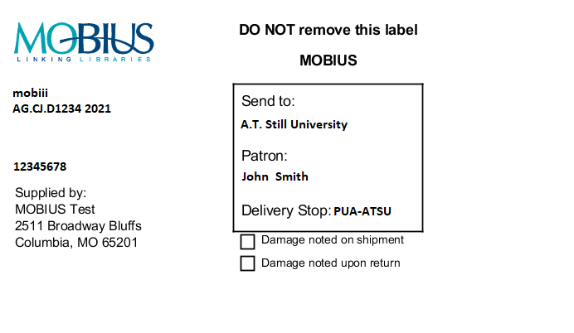
    - Example 2:

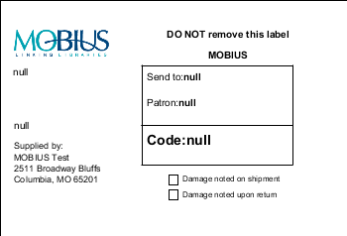

- Steve mentioned that there is a limited amount variation we can encode using the print template technology that Innovative currently uses. For example, the only thing we can do is change the font size or bolding of the pickup name.
- All the requests go in the same pile for the paging lists and use the same template, so what was changed was the print name, so it says FONT" for a normal Fontbonne request, and "PUA-FONT" for a PUA request.
- Sarah Francka-Jones and others mentioned it would be nice to have some visual indication that the label was inherently different. We will check with Innovative to see if perhaps more can be done here.

- New Business
  - Open discussion.
    - Lisa Young mentioned that Lindenwood began printing ID cards using a chip (instead of a scan-able barcode or magnetic strip). At the start of this semester, we have transitioned to mobile credentials, which is super cool. However, one of my co-workers posed the question “Will mobile credentials, that serve as an ID card, be accepted at other MOBIUS library’s for Visiting Patron transactions?” Lindenwood’s mobile credentials display an ID photo and the ID number, so I want to answer yes, this would be acceptable and in accordance to the MOBIUS policy:
The visiting patron must be able to present a current, valid ID card from their home institution. If an institution does not provide their students or faculty with picture IDs, the visiting patron must be able to show some other form of picture ID, such as a driver’s license, upon request. Materials cannot be checked out to anyone who cannot present their ID card. Use Visiting Patron ID examples and special notes to aid in entering correct number format located at: http://mobiusconsortium.org/node/5299
Do you two think this would be commonly accepted as an “ID card” since it meets the criteria? Or should I present this on the MOBIUS-Users List? Or bring it up at the next Circ/Courier meeting?
      - Steve mentioned this might be a good idea for the MOBIUS Board to consider given that a policy is potentially in conflict, but that it should be a matter of updating it since the technology is now allowing for a different kind of ID to be created and used.
      - No on expressed any reservation at using the new kind of card.

- Adjourn Meeting – next meeting is Monday, March 14th at 10:00 am.

